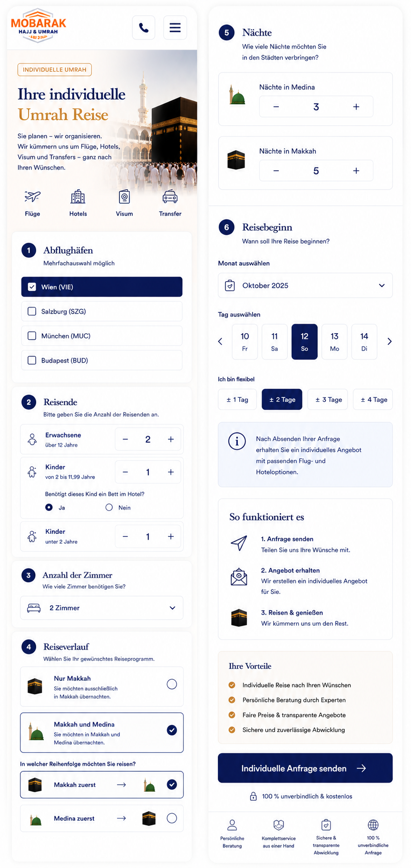
Developer Specification – Individual Umrah Inquiry Page
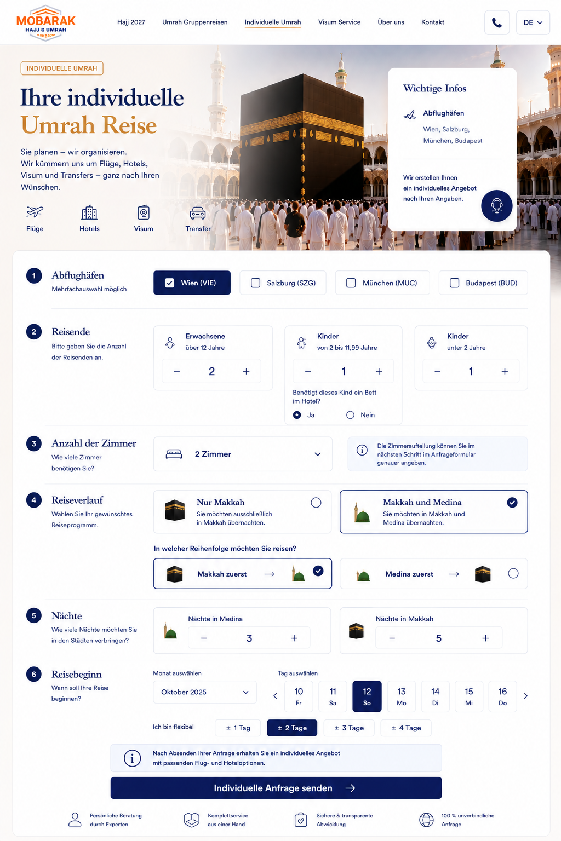
Please build the Individual Umrah inquiry page according to the approved desktop and mobile designs.
This page is for customers who do not want to book a fixed Umrah group trip. Instead, they tell us their requirements and we create an individual offer including flights, hotels, visa and transfers.
The entire flow should be simple, visual and dynamic.

1. Purpose of the Page
Main message:
Ihre individuelle Umrah Reise
Sie planen – wir organisieren.
Wir kümmern uns um Flüge, Hotels, Visum und Transfers – ganz nach Ihren Wünschen.
The customer provides:
- Preferred departure airport(s)
- Number of travellers
- Number of rooms
- Whether they want only Makkah or Makkah + Medina
- Order of the cities
- Number of nights
- Preferred departure date
- Date flexibility
After submission, Mobarak receives the request and prepares an individual offer.
This is therefore an:
Inquiry flow, not an immediate booking checkout.

2. General Design
Please follow the supplied design closely.
Main visual style:
- White / warm off-white background
- Dark navy typography
- Gold/orange accents
- Mobarak blue for selected fields and primary CTA
- Green only where positive availability/status information is needed
- Light grey borders
- Rounded cards
- Very subtle shadows
- High-quality Makkah / Medina imagery
- Large, clean form fields
- Plenty of whitespace
The page should feel:
premium, simple, trustworthy and easy to complete.

3. Header
Desktop
Use the normal Mobarak navigation.
Logo:
MOBARAK HAJJ & UMRAH
Navigation:
- Hajj 2027
- Umrah Gruppenreisen
- Individuelle Umrah
- Visum Service
- Über uns
- Kontakt
Highlight:
Individuelle Umrah
as the active navigation item.
Right side:
- Telephone
- Language selector

4. Mobile Header
On mobile display only:
Left: Mobarak logo
Right:
- Phone icon
- Hamburger menu
Do not show the full desktop menu.
Keep the mobile header approximately 64–72px high.

5. Hero Section
Use a strong Makkah / Kaaba image.
Small label:
INDIVIDUELLE UMRAH
Headline:
Ihre individuelle
Umrah Reise
Body:
Sie planen – wir organisieren.
Wir kümmern uns um Flüge, Hotels, Visum und Transfers – ganz nach Ihren Wünschen.
Show four service icons:
✈️ Flüge
🏨 Hotels
📘 Visum
🚌 Transfers
On desktop, optionally show a small information card on the right:
Wichtige Infos
Abflughäfen
Wien, Salzburg, München, Budapest
Text:
Wir erstellen Ihnen ein individuelles Angebot nach Ihren Angaben.

6. Form Structure
The form should use numbered steps.
Order:
1. Abflughäfen
2. Reisende
3. Anzahl der Zimmer
4. Reiseverlauf
5. Nächte
6. Reisebeginn
Then:
- Information box
- CTA
- Trust elements

7. Step 1 – Departure Airports
Heading:
1. Abflughäfen
Helper text:
Mehrfachauswahl möglich
Available airports:
- Wien (VIE)
- Salzburg (SZG)
- München (MUC)
- Budapest (BUD)
Important:
Multiple selection must be possible.
Example:
Customer can select:
☑ Wien
☑ München
at the same time.
This means:
Checkbox behavior, not radio-button behavior.
Selected airport:
- Dark Mobarak blue background
- White text
- White checkmark
Unselected:
- White background
- Light border
- Dark navy text
At least one departure airport must be selected.

8. Step 2 – Travellers
Heading:
2. Reisende
Helper:
Bitte geben Sie die Anzahl der Reisenden an.
Create three separate counters.

Adults
Erwachsene
über / ab 12 Jahre
Counter:
− 2 +
Minimum should normally be:
1 adult

Children
Kinder
2 bis 11,99 Jahre bei Rückreise
Counter:
− 0 +

Babies / Infants
The label should be:
Babys
unter 2 Jahre bei Rückreise
Do not call this simply “Kinder unter 2 Jahre” in the final interface.
Counter:
− 0 +

9. Age Rule
The age category must be determined by the traveller's age on the return date, not on the date when the inquiry is submitted.
Important for future logic:
- Adult: 12+ on return date
- Child: 2–11.99 on return date
- Infant: under 2 on return date
At this stage we are collecting counts only, but the data model should allow this rule later.

10. Child Bed Requirement
If the customer selects one or more children aged 2–11.99, an additional question must automatically appear.
Question:
Benötigt das Kind ein Bett im Hotel?
Options:
○ Ja
○ Nein
No default selection.

11. Multiple Children
If there is only one child:
Show one bed question.
If there are multiple children, ideally ask this per child.
Example:
Kind 1
Benötigt das Kind ein eigenes Bett?
○ Ja
○ Nein
Kind 2
Benötigt das Kind ein eigenes Bett?
○ Ja
○ Nein
This is important because one child may need a bed and another may not.

12. Step 3 – Number of Rooms
Heading:
3. Anzahl der Zimmer
Question:
Wie viele Zimmer benötigen Sie?
Use either:
- Select dropdown, or
- Large plus/minus counter
The approved design currently shows a clean dropdown such as:
🏨 2 Zimmer ▼
Recommended values:
1
2
3
4
5
6+
For 6+ you may allow a custom number.

13. Room Count Logic
The room count is independent from the number of travellers.
Example:
4 travellers could request:
- 1 room
- 2 rooms
- 3 rooms
Do not automatically calculate the room count without allowing the customer to change it.
At this stage, we only need:
Number of rooms
The exact room allocation can either be handled later in the inquiry process or by Mobarak when preparing the offer.
Optional helper text:
Die genaue Zimmeraufteilung können Sie im nächsten Schritt bzw. bei der Angebotserstellung angeben.

14. Step 4 – Travel Route
Heading:
4. Reiseverlauf
Question:
Wählen Sie Ihr gewünschtes Reiseprogramm.
Show two large selectable cards.

Option A
Nur Makkah
Text:
Sie möchten ausschließlich in Makkah übernachten.

Option B
Makkah und Medina
Text:
Sie möchten in Makkah und Medina übernachten.
Only one option can be selected.
Use radio-card behavior.

15. Conditional Route Question
If customer selects:
Nur Makkah
Do NOT show another city-order question.
Proceed directly to nights.

If customer selects:
Makkah und Medina
automatically show:
In welcher Reihenfolge möchten Sie reisen?
Then show:
Makkah zuerst
🕋 → 🕌
and:
Medina zuerst
🕌 → 🕋
Only one option can be selected.
No default selection.

16. Step 5 – Number of Nights
Heading:
5. Nächte
Question:
Wie viele Nächte möchten Sie in den Städten verbringen?

If “Makkah + Medina” selected
Show two separate counters:
Nächte in Medina
− 3 +
Nächte in Makkah
− 5 +

If “Nur Makkah” selected
Hide the Medina field completely.
Only show:
Nächte in Makkah
− 5 +
Do not display a disabled Medina field.

17. Nights Validation
Minimum:
At least 1 night in every selected city.
Do not allow negative numbers or zero nights for a city that is included in the itinerary.
The maximum can remain configurable.

18. Step 6 – Travel Start Date
Heading:
6. Reisebeginn
Question:
Wann soll Ihre Reise beginnen?
The customer should first select:
Month
and then:
Day

19. Month Selection
Use a dropdown:
Monat auswählen
Example:
October 2026
November 2026
December 2026
January 2027
Do not hard-code the old example year from the mockup.
The available months should be dynamic.
Ideally allow upcoming travel dates for approximately the next 12–18 months.

20. Day Selection
After the month is chosen, show a horizontal day selector.
Example:
‹ 10 Fr | 11 Sa | 12 So | 13 Mo | 14 Di | 15 Mi | 16 Do ›
Selected day:
- Dark blue background
- White text
User can navigate left/right.
On mobile this should support horizontal swipe.

21. Flexibility
Below the selected date show:
Ich bin flexibel
Options:
± 1 Tag
± 2 Tage
± 3 Tage
± 4 Tage
Only one flexibility option should be selected.
Also allow:
Nicht flexibel
either as:
Genau dieses Datum
or by allowing no flexibility option to be selected.
Recommended final options:
- Genau dieses Datum
- ± 1 Tag
- ± 2 Tage
- ± 3 Tage
- ± 4 Tage
This makes the logic clearer than having no visible “not flexible” state.

22. Flexibility Meaning
Example:
Selected travel start:
12 October
and:
± 2 days
means Mobarak may search departures between:
10 October and 14 October.
Store both:
- requested_start_date
- flexibility_days
Do not modify the original selected date.

23. Information Box Before Submission
Show an information box:
ℹ️
Nach Absenden Ihrer Anfrage erhalten Sie ein individuelles Angebot mit passenden Flug- und Hoteloptionen.
This must be clearly visible but should not look like a warning.

24. Primary CTA
Button:
Individuelle Anfrage senden →
Use Mobarak dark blue.
Desktop:
Centered inside the form area.
Mobile:
Nearly full width.
No sticky button is required for this page unless we decide otherwise later.

25. Trust Elements
Below the CTA show:
Persönliche Beratung durch Experten
Komplettservice aus einer Hand
Sichere & transparente Abwicklung
100 % unverbindliche Anfrage
Use simple dark navy icons.

26. Mobile Layout
Mobile must NOT simply shrink the desktop version.
Use one vertical column.
Order:
Header
↓
Hero
↓
Services
↓
1. Abflughäfen
↓
2. Reisende
↓
3. Anzahl der Zimmer
↓
4. Reiseverlauf
↓
5. Nächte
↓
6. Reisebeginn
↓
So funktioniert es
↓
Ihre Vorteile
↓
Individuelle Anfrage senden

27. Mobile Departure Airports
Display airports vertically as large tap targets:
☑ Wien (VIE)
☐ Salzburg (SZG)
☐ München (MUC)
☐ Budapest (BUD)
Multiple selection must work.
Do not place all four in a tiny horizontal row on narrow screens.

28. Mobile Traveller Section
Display vertically:
Erwachsene
ab 12 Jahre
− 2 +
Kinder
2–11,99 Jahre
− 1 +
If children > 0:
Benötigt dieses Kind ein Bett im Hotel?
○ Ja
○ Nein
Babys
unter 2 Jahre
− 0 +
Large touch-friendly + / − buttons.

29. Mobile Room Count
Full-width card:
Anzahl der Zimmer
🏨 2 Zimmer ▼
The customer should be able to tap the entire field.

30. Mobile Travel Route
Show:
Nur Makkah
full-width selectable card
and below:
Makkah und Medina
full-width selectable card.
If Makkah + Medina is selected, dynamically reveal:
In welcher Reihenfolge möchten Sie reisen?
Then:
Makkah zuerst → Medina
and:
Medina zuerst → Makkah
as two separate full-width options.

31. Mobile Nights
Show vertically:
Nächte in Medina
large counter
then:
Nächte in Makkah
large counter
Do not put both next to each other on narrow screens.

32. Mobile Date Selector
Month:
Full-width dropdown.
Day:
Horizontal swipe carousel.
Example:
10 | 11 | 12 | 13 | 14
with left/right arrows.
Flexibility buttons can use a 2-column layout:
±1 Tag | ±2 Tage
±3 Tage | ±4 Tage
or horizontal swipe if necessary.

33. “So funktioniert es” Mobile Section
After the form information, show a simple three-step explanation:
1. Anfrage senden
Teilen Sie uns Ihre Wünsche mit.
2. Angebot erhalten
Wir erstellen ein individuelles Angebot für Sie.
3. Reisen & genießen
Wir kümmern uns um den Rest.
Use simple icons.

34. Mobile Advantages
Section:
Ihre Vorteile
✓ Individuelle Reise nach Ihren Wünschen
✓ Persönliche Beratung durch Experten
✓ Faire Preise & transparente Angebote
✓ Sichere und zuverlässige Abwicklung

35. Future Contact Details
Important technical point:
The current design focuses on travel requirements, but an actual inquiry needs customer contact information.
Therefore the final production form should also include at least:
Vorname
Nachname
Telefonnummer
E-Mail-Adresse (optional)
Bevorzugte Sprache
Preferred language should automatically follow the selected website language but remain editable.
This can be added as the final form step before submission.
Without at least a phone number, we cannot respond to the inquiry.

36. Recommended Contact Section
Add:
7. Kontaktdaten
Fields:
Vorname
Nachname
Telefonnummer
E-Mail-Adresse (optional)
Bevorzugte Sprache
Language logic:
German page → Deutsch
Arabic → العربية
Turkish → Türkçe
Bosnian → Bosanski
English → English
Customer can change the default.

37. Telephone Field
Use:
Country flag | Country prefix | Phone number
Default phone country may follow the website/location context where appropriate, but the customer must always be able to change it.

38. “How Did You Find Us?”
I also recommend using the same field used in the other inquiry forms:
Wo haben Sie uns gefunden?
Options:
- Instagram
- Facebook
- Google
- ChatGPT
- Empfohlen von einem Freund
- Ich kenne euch schon
- Andere
No default selection.
This can be included before the final CTA.

39. Form Validation
Required:
- At least one departure airport
- At least one adult
- Number of rooms
- Route
- City order if both cities selected
- Nights
- Start date
- Bed requirement for every child where applicable
- First name
- Last name
- Phone number
Optional:
- Email
- Flexibility
- Marketing source depending on business requirement
Show validation underneath the relevant field.
Do not only show one generic error at the top.

40. Conditional Logic Summary
Airport
Multi-select.

Child count > 0
Show bed question(s).

Only Makkah
Hide:
- Medina-first / Makkah-first question
- Medina nights

Makkah + Medina
Show:
- City-order question
- Medina nights
- Makkah nights

Month selected
Load relevant days.

Flexibility selected
Save allowed ± day range.

41. Backend Data Structure
The inquiry should store structured data.
Example:
Inquiry
- inquiry_id
- created_at
- language
- status
Airports
Array:
- VIE
- SZG
- MUC
- BUD
Travellers
- adult_count
- child_count
- infant_count
Children
For each child:
- requires_bed: true / false
Rooms
- room_count
Route
- makkah_only
or
- makkah_medina
City order
- makkah_first
- medina_first
- null if Makkah only
Nights
- makkah_nights
- medina_nights
Travel date
- start_month
- requested_start_date
- flexibility_days
Contact
- first_name
- last_name
- phone_country_code
- phone_number
- email
- preferred_language
Marketing
- source

42. Admin Requirements
Admin should be able to manage:
- Available departure airports
- Airport labels/codes
- Minimum/maximum traveller counts
- Available room-count options
- Minimum/maximum nights
- Available months
- Date availability if needed
- Service icons/texts
- Hero text/image
- CTA text
- Translations
- Inquiry status
Admin should also be able to view each submitted inquiry clearly.

43. Admin Inquiry Summary
Each inquiry should show something like:
Individual Umrah Inquiry #1024
Departure airports: Vienna + Munich
Travellers:
2 adults
1 child
0 infants
Child bed: Yes
Rooms: 2
Route: Makkah + Medina
Order: Medina first
Medina: 3 nights
Makkah: 5 nights
Preferred departure: 12 October 2026
Flexibility: ±2 days
Customer:
First Name / Last Name
Phone
Email
Preferred language
This should be easy for our team to read without manually decoding raw form data.

44. Multilingual Requirement
The complete page must support:
- German
- Arabic
- Turkish
- Bosnian
- English
Arabic must use a true RTL implementation.
This includes:
- Form labels
- Counters
- Cards
- City direction
- Arrows
- Date selectors
- CTA
- Error messages
- Information boxes
For Arabic, directional UI such as:
Makkah → Medina
must also be checked carefully to make sure the travel sequence remains semantically correct while the surrounding page is RTL.

45. UX Principle
The form should react immediately to what the customer selects.
Do not show irrelevant questions.
Example:
If the customer wants only Makkah, asking:
Makkah first or Medina first?
would make no sense and therefore must not appear.
The desired experience is:
Tell us what you need → only see relevant questions → submit → receive an individual offer.

46. Final Desktop Flow
Hero
↓
1. Departure airports
↓
2. Travellers
↓
3. Number of rooms
↓
4. Travel route
↓
5. Nights
↓
6. Travel start
↓
7. Contact details
↓
How did you find us?
↓
Information box
↓
Individuelle Anfrage senden →

47. Final Mobile Flow
Compact Header
↓
Hero
↓
Flights · Hotels · Visa · Transfers
↓
Departure airports
↓
Travellers
↓
Number of rooms
↓
Travel route
↓
Nights
↓
Travel start + flexibility
↓
Contact details
↓
How did you find us?
↓
How it works
↓
Advantages
↓
Individuelle Anfrage senden →
The page should remain clean and easy to complete even when many conditional fields become visible.

Individual Umrah Inquiry – Final Developer Specification
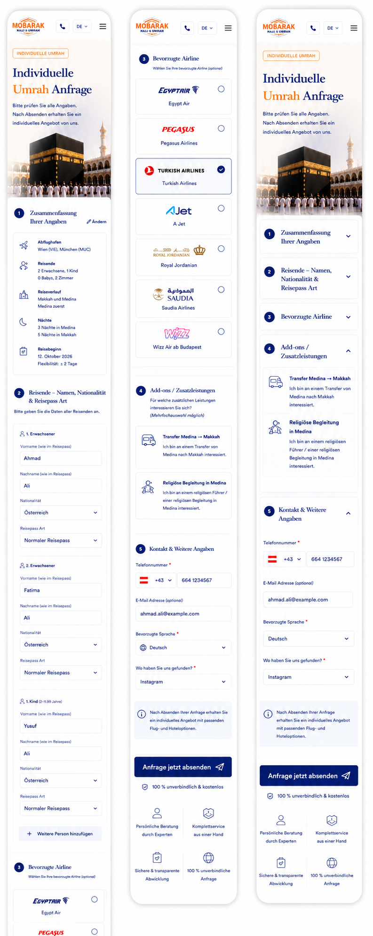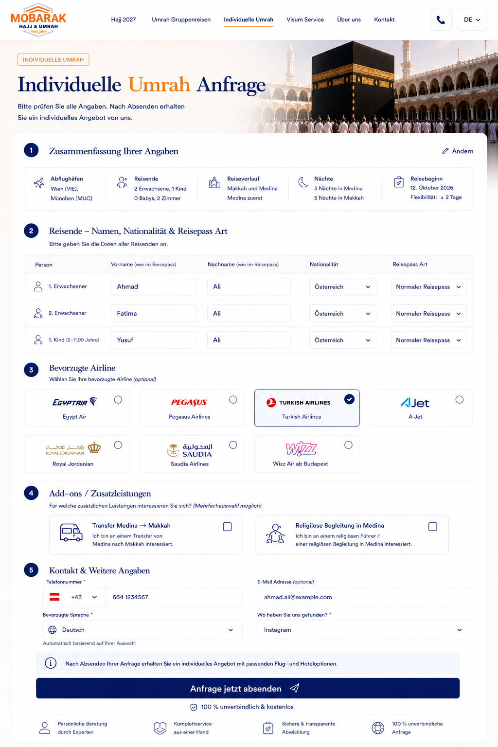
Please use the attached/final approved designs as the reference for the Individual Umrah Inquiry.
We have now selected the final Desktop and Mobile versions.
The implementation should follow these designs very closely regarding:
- Layout
- Spacing
- Typography
- Colors
- Icons
- Borders
- Card sizes
- Form field sizes
- Section structure
- Responsive behavior
Please do not redesign the page during implementation.

1. Purpose of the Page
This is the final step of the Individual Umrah Inquiry.
The customer has already configured the basic trip requirements in the previous step.
On this page they should:
- Review their travel request
- Enter the personal details of all travellers
- Select a preferred airline
- Select optional add-ons
- Enter contact details
- Tell us how they found us
- Submit the inquiry
This is an inquiry, not a confirmed booking.

2. Desktop Layout
The Desktop version should use the approved wide layout.
Important:
There should be NO right sidebar.
Everything should be displayed inside one central content container.
Recommended maximum width:
approximately 1200–1300px
The page should remain centered even on very large monitors.
Do not stretch the content indefinitely across the screen.

3. Mobile Layout
The approved narrow iPhone design should be used.
The Mobile version should be a single-column layout.
Do not simply scale down the Desktop layout.
Form fields, airline cards and traveller information must rearrange properly for small screens.

4. Mobile Header
Mobile header:
Left:
Mobarak Hajj & Umrah logo
Right:
- Phone button
- Language selector
- Hamburger menu
Keep the header compact.

5. Hero Section
Use the same visual concept on Desktop and Mobile.
Label:
INDIVIDUELLE UMRAH
Headline:
Individuelle Umrah Anfrage
Text:
Bitte prüfen Sie alle Angaben. Nach Absenden erhalten Sie ein individuelles Angebot von uns.
Use a Makkah / Kaaba image on the right/background.
On Mobile, the image should remain clearly visible but must not make the hero excessively tall.

6. Section 1 – Zusammenfassung Ihrer Angaben
Heading:
1. Zusammenfassung Ihrer Angaben
Desktop:
Show the information horizontally.
Mobile:
Show the information vertically in a clean summary card.
Information:
Abflughäfen
Example:
Wien (VIE)
München (MUC)
Reisende
Example:
2 Erwachsene, 1 Kind
0 Babys, 2 Zimmer
Reiseverlauf
Example:
Makkah und Medina
Medina zuerst
Nächte
Example:
3 Nächte in Medina
5 Nächte in Makkah
Reisebeginn
Example:
- Oktober 2026
Flexibilität: ± 2 Tage
Include:
Ändern
The customer can return to the previous configuration step without losing the already entered information.

7. Mobile Section Behaviour
In the Mobile design, the sections can visually use the accordion-style headers shown in the approved design.
However:
All sections should be OPEN by default.
The customer should not have to open every section manually.
They may optionally collapse a section themselves afterwards.
Default:
- Section 1 → Open
- Section 2 → Open
- Section 3 → Open
- Section 4 → Open
- Section 5 → Open

8. Section 2 – Traveller Information
Heading:
2. Reisende – Namen, Nationalität & Reisepass Art
Text:
Bitte geben Sie die Daten aller Reisenden an.
The number of traveller forms must automatically correspond to the traveller configuration from the previous step.
Example:
2 adults + 1 child
Automatically create:
1. Erwachsener
2. Erwachsener
1. Kind
Do not ask the customer to manually add these travellers again.

9. Desktop Traveller Layout
Desktop should use one horizontal row per traveller.
Columns:
Person
Vorname (wie im Reisepass)
Nachname (wie im Reisepass)
Nationalität
Reisepass Art
Example:
1. Erwachsener | Ahmad | Ali | Österreich | Normaler Reisepass

10. Mobile Traveller Layout
On Mobile, every traveller receives their own vertical block.
Example:
1. Erwachsener
Vorname (wie im Reisepass)
[ Ahmad ]
Nachname (wie im Reisepass)
[ Ali ]
Nationalität
[ Österreich ▼ ]
Reisepass Art
[ Normaler Reisepass ▼ ]
Then immediately:
2. Erwachsener
etc.
All traveller blocks should already be visible.

11. Nationality
Nationality should be a searchable autocomplete field.
The customer should be able to start typing the country.
Example:
Öst...
→ Österreich
Bos...
→ Bosnien und Herzegowina
Tür...
→ Türkei
Do not force users to scroll through a huge country dropdown.

12. Passport Type
Available options:
- Normaler Reisepass
- Konventionspass
- Travel Document
- Diplomatenpass
No passport number is required at this inquiry stage.

13. Do Not Use “Weitere Person hinzufügen”
The number of traveller fields should come from the previous travel configuration.
Therefore the production version should not require:
+ Weitere Person hinzufügen
for travellers that are already part of the inquiry.
If 5 travellers were selected previously, automatically show 5 traveller forms.

14. Section 3 – Preferred Airline
Heading:
3. Bevorzugte Airline
Text:
Wählen Sie Ihre bevorzugte Airline (optional)
This section is optional.
Airlines:
- Egypt Air
- Pegasus Airlines
- Turkish Airlines
- AJet
- Royal Jordanian
- Saudia Airlines
- Wizz Air ab Budapest
Use the airline logos as shown in the design.

15. Airline Selection
The cards should be large and easy to select.
Unselected:
- White background
- Light border
- Airline logo
- Airline name
- Empty selection circle
Selected:
- Blue border
- Very subtle blue background
- Blue filled selection indicator/check
Only one preferred airline should be selectable.
The customer should also be able to submit the form without selecting an airline.

16. Section 4 – Add-ons / Zusatzleistungen
Heading:
4. Add-ons / Zusatzleistungen
Text:
Für welche zusätzlichen Leistungen interessieren Sie sich?
Additional helper:
Mehrfachauswahl möglich
Unlike the airline section, these are checkboxes.
The customer may select:
- None
- One
- Two
- All add-ons

17. Add-on 1 – Transfer Medina → Makkah
Please change the current Bus icon.
Use a TRAIN icon.
Do NOT use a bus icon.
Title:
Transfer Medina → Makkah
Text:
Ich bin an einem Transfer von Medina nach Makkah interessiert.
This mainly refers to arranging the transfer between the two cities, for example by train depending on the final offer.
Use a clear train / high-speed rail line icon.

18. Add-on 2 – Religious Guide in Medina
Use a suitable religious guide/person icon.
Title:
Religiöse Begleitung in Medina
Text:
Ich bin an einem religiösen Führer / einer religiösen Begleitung in Medina interessiert.

19. NEW Add-on 3 – Visa
Please add a third Add-on:
Visum
Use a passport / visa icon consistent with the other outline icons.
Title:
Visum
Text:
Ich bin an der Organisation des Visums für meine Umrah-Reise interessiert.
This should work exactly like the other add-ons.
Checkbox:
☐ Visum
No default selection.

20. Add-ons Desktop Layout
With three Add-ons, please keep the layout balanced.
Recommended Desktop:
Three cards in one row if there is enough space:
Transfer Medina → Makkah
Religiöse Begleitung in Medina
Visum
Alternatively, if the cards become too narrow, use:
2 cards first row
1 card second row
But do not reduce the text excessively just to force all three into one row.

21. Add-ons Mobile Layout
Mobile:
All Add-ons should appear underneath each other.
Transfer Medina → Makkah
🚆
Description
☐
Religiöse Begleitung in Medina
Guide icon
Description
☐
Visum
Passport icon
Description
☐
The complete card should ideally be clickable, not only the small checkbox.

22. Conditional Add-on Logic
Please make the Add-ons intelligent based on the itinerary.
If Makkah + Medina is selected:
Show:
- Transfer Medina → Makkah
- Religiöse Begleitung in Medina
- Visum
If only Makkah is selected:
Hide:
- Transfer Medina → Makkah
- Religiöse Begleitung in Medina
Show:
- Visum
There is no reason to offer a Medina service if Medina is not part of the customer's itinerary.

23. Important Transfer Logic
If the itinerary is:
Medina zuerst → Makkah
show:
Transfer Medina → Makkah
If the customer selects:
Makkah zuerst → Medina
the wording should automatically change to:
Transfer Makkah → Medina
The icon remains the train icon.
The description should also change dynamically:
Ich bin an einem Transfer von Makkah nach Medina interessiert.
Therefore this Add-on should technically be a:
City-to-city transfer
with its displayed direction based on the selected itinerary.

24. Section 5 – Kontakt & Weitere Angaben
Heading:
5. Kontakt & Weitere Angaben
Fields:
Telefonnummer *
E-Mail Adresse (optional)
Bevorzugte Sprache *
Wo haben Sie uns gefunden? *

25. Telephone Number
Default country:
🇦🇹 +43 Austria
The customer must be able to change the country code.
Layout Desktop:
🇦🇹 +43 ▼ | 664 1234567
Mobile:
Keep country code and phone number on the same line if enough width is available.
If the screen becomes too narrow, prioritize usability rather than squeezing the fields.

26. Email
Label:
E-Mail Adresse (optional)
Email remains optional.

27. Preferred Language
Label:
Bevorzugte Sprache
The preferred language should automatically follow the website language.
Example:
German website → Deutsch
Arabic website → العربية
Turkish website → Türkçe
Bosnian website → Bosanski
English website → English
The customer can manually change the language afterwards.

28. “Wo haben Sie uns gefunden?”
Label:
Wo haben Sie uns gefunden?
No default selection.
Options:
- Instagram
- Facebook
- Google
- ChatGPT
- Empfohlen von einem Freund
- Ich kenne euch schon
- Andere
If:
Andere
is selected, show a small additional text field.

29. Information Box
Immediately above the CTA show:
ⓘ Nach Absenden Ihrer Anfrage erhalten Sie ein individuelles Angebot mit passenden Flug- und Hoteloptionen.
Use the subtle light-blue information box exactly as shown in the approved design.

30. Main CTA
Button:
Anfrage jetzt absenden
Use:
- Dark Mobarak blue
- White text
- Send/paper-plane icon
- Rounded corners
Desktop:
Button spans the form content width as shown in the design.
Mobile:
Button should be almost full width of the form container.
Do NOT make this button sticky.
It stays at the natural bottom of the form.

31. Below CTA
Show:
🛡 100 % unverbindlich & kostenlos
Then the four trust elements:
Persönliche Beratung durch Experten
Komplettservice aus einer Hand
Sichere & transparente Abwicklung
100 % unverbindliche Anfrage
Desktop:
Display horizontally.
Mobile:
Use a clean 2 × 2 grid.

32. Submission Validation
Required:
- First name of every traveller
- Last name of every traveller
- Nationality of every traveller
- Passport type of every traveller
- Telephone number
- Preferred language
- “Wo haben Sie uns gefunden?”
Optional:
- Preferred airline
- Add-ons
- Email
The customer must be allowed to submit without choosing any Airline or Add-on.

33. Do Not Lose Previous Travel Data
When the customer reaches this final form, all information from the previous Individual Umrah configuration must already be available.
This includes:
- Departure airport(s)
- Adults
- Children
- Babies
- Child bed requirements
- Number of rooms
- Makkah only / Makkah + Medina
- City order
- Makkah nights
- Medina nights
- Departure date
- Flexibility
If the customer presses:
Ändern
and returns to modify something, do not delete the personal information they have already entered.
Preserve the state whenever possible.

34. Responsive Behaviour
The Desktop and Mobile designs are both approved.
Please do not treat the Mobile screenshot as a completely different page.
Both views represent the same form and the same data.
Responsive transition:
Desktop
Wide rows, horizontal summary, horizontal traveller table, airline grid.
Tablet
Reduce columns progressively.
Mobile
Single-column form, traveller cards, vertically stacked Add-ons and responsive airline cards.

35. Mobile – Important Final Decision
Please use the selected Mobile design as the visual reference.
However:
All sections should be expanded by default.
The accordion arrows can remain because users may manually collapse sections.
But when the page initially loads, the customer should immediately be able to scroll through all information without opening sections.
This includes:
1 – Zusammenfassung Ihrer Angaben
2 – Reisende
3 – Bevorzugte Airline
4 – Add-ons / Zusatzleistungen
5 – Kontakt & Weitere Angaben
Everything is initially visible.

36. Final Add-on Structure
The final Add-ons are therefore:
🚆 Transfer zwischen Medina & Makkah
Direction automatically follows itinerary.
Religious guide icon – Religiöse Begleitung in Medina
Only shown when Medina is included.
Passport/Visa icon – Visum
Shown for all Individual Umrah inquiries.
All three are optional and support multiple selection.

37. Final Design Rule
Please reproduce the approved Desktop and Mobile screenshots as closely as technically possible.
Do not introduce new visual components unless required for responsive behavior.
The most important principles are:
clean
premium
easy to understand
not overcrowded
mobile-friendly
consistent with the Mobarak Hajj & Umrah branding
The customer should be able to review the entire Individual Umrah request, complete the traveller details and submit the inquiry without confusion.
PDF OFFER:
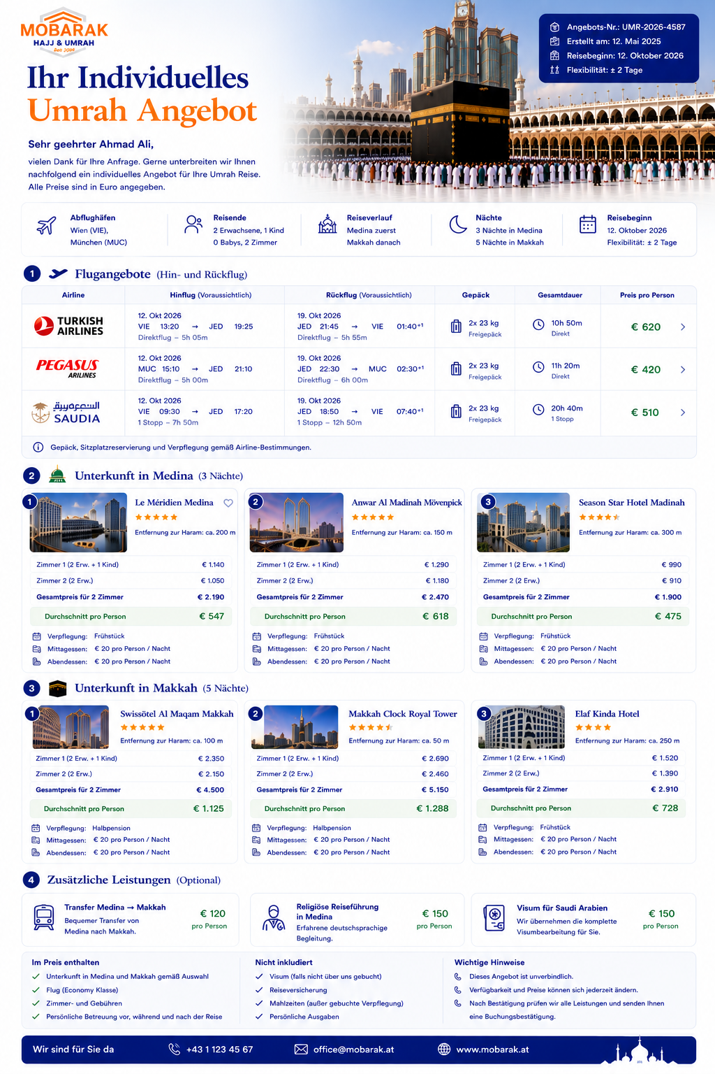
Developer Specification – Individual Umrah Admin, Pricing & Automatic PDF Offers
Please use the attached approved PDF design as the final visual reference for the automatically generated Individual Umrah offer.
The goal is to create an internal system where we can maintain hotels and hotel rates, manually enter suitable flight offers for an inquiry, select optional services, and then automatically generate a professional PDF offer for the customer.
The process should be:
Customer submits Individual Umrah inquiry → Inquiry appears in Admin → We select/add hotel and flight options → System calculates prices → PDF is generated automatically → We download the PDF and send it to the customer.

1. Additional question in the Individual Umrah inquiry form
Before the customer submits the original Individual Umrah inquiry, add the following section:
Was ist Ihnen bei Ihrer Reise wichtig?
Subtitle:
Markieren Sie bitte die Punkte, die Ihnen besonders wichtig sind.
Mehrfachauswahl möglich
The following options should be available as checkboxes:
Nähe zum Haram ist mir wichtig
Luxushotel ist mir wichtig
Ein günstiger Preis ist mir wichtig
Ich brauche ausreichend Gepäck
Gepäck ist mir nicht so wichtig
There should be no default selection.
The customer can select several options.
For example:
✓ Nähe zum Haram
✓ Luxushotel
✓ Ich brauche ausreichend Gepäck
This information should be visible prominently inside the Admin inquiry because it helps us choose appropriate hotels and flights.

2. Individual Umrah inquiries in Admin
Every Individual Umrah inquiry should create an inquiry record.
The Admin should clearly show the information collected from the customer, including:
- Inquiry number
- Customer name
- Telephone
- Email
- Preferred language
- Departure airports
- Adults
- Children
- Infants
- Child bed requirements
- Number of rooms
- Makkah only / Makkah + Medina
- Makkah first / Medina first
- Nights in Medina
- Nights in Makkah
- Requested departure date
- Date flexibility
- Preferred airline
- Add-ons requested
- What is important to the customer
- How they found us
- Inquiry status
Suggested statuses:
New inquiry
Offer in preparation
Offer created
Offer sent
Customer interested
Booked
Cancelled

3. Hotel database
I need a hotel management section in Admin.
Hotels should be separated into:
Hotels in Medina
and
Hotels in Makkah
Each hotel should only need to be created once.
For every hotel we should be able to store:
Hotel name
City
Star rating
Hotel images
Distance from Haram
Description
Available meal plans
General notes
Active / inactive

4. Hotel pricing
This is very important.
Hotel prices must support different prices depending on travel dates.
Example:
Hotel A – Medina
20 September – 20 October
€100 per room / night
20 October – 20 December
€150 per room / night
The Admin should therefore allow us to create unlimited date-based rate periods.
Each rate period requires at minimum:
Valid from
Valid until
Room price

5. Weekday and weekend prices
We also need the possibility to define different prices depending on the day of the week.
Example:
Sunday–Thursday:
€100 per room/night
Friday–Saturday:
€130 per room/night
The hotel rate engine must calculate the correct total according to every night of the stay.
For example:
5-night stay containing:
3 weekdays × €100
2 weekend nights × €130
The system calculates the hotel total automatically.
Do not simply multiply all nights by one average price.

6. Multiple seasonal rate periods
The same hotel may have many periods.
For example:
Period | Weekday | Weekend
01 Sep – 20 Oct | €100 | €120
21 Oct – 20 Dec | €150 | €175
21 Dec – 10 Jan | €250 | €290
11 Jan – 28 Feb | €130 | €150
We need to be able to add/edit/delete these periods from Admin without changing code.

7. Room categories
Ideally hotel prices should also support different room categories.
For example:
Standard Room
Deluxe Room
Triple Room
Family Room
etc.
For each category we need its own rate rules if required.
This allows us later to expand the system without rebuilding the pricing engine.

8. Extra bed
For every hotel/rate we need the possibility to define an extra-bed price.
Example:
Extra bed including breakfast
€30 per night
This extra-bed price should be used by the pricing calculation when necessary.
Important:
Do NOT show “Extra bed €30/night” as a separate price line in the customer PDF.
We previously decided to remove the separate extra-bed price from the final PDF.
The extra-bed rate is an internal calculation value.
The customer PDF should show the final calculated price of the relevant room.
Example:
Zimmer 1 – 2 Erwachsene + 1 Kind
€1,140 total
The customer does not need to see how much of the €1,140 came from the extra bed.

9. Meals
For every hotel we need configurable meal pricing.
At minimum:
Breakfast
Can be:
- included
- optional
- price configurable
Lunch
Example:
€20 per person / night
Dinner
Example:
€20 per person / night
The hotel can therefore have, for example:
Verpflegung: Frühstück
Mittagessen: €20 pro Person / Nacht
Abendessen: €20 pro Person / Nacht
These prices should be editable by hotel and, if necessary, by rate period.

10. Hotel calculation for an inquiry
Example customer:
2 adults
1 child
2 rooms
Medina:
3 nights
The Admin selects:
Le Méridien Medina
The system should calculate:
Zimmer 1 – 2 Erwachsene + 1 Kind
€1,140
Zimmer 2 – 2 Erwachsene
€1,050
Then:
Gesamtpreis für 2 Zimmer
€2,190
Then calculate:
Durchschnitt pro Person
Automatically calculated according to the total number of paying travellers used for the offer.
The PDF displays this amount in green.

11. Multiple rooms must be shown separately
If the inquiry has more than one room, each room must be shown separately in the offer.
Example:
Zimmer 1
2 Erwachsene + 1 Kind
€1,140
Zimmer 2
2 Erwachsene
€1,050
Gesamtpreis für 2 Zimmer
€2,190
Durchschnitt pro Person
€547
Do NOT display only one combined room price without showing the room allocation.

12. Medina and Makkah hotel dates
The hotel sections in the PDF must always show the actual stay dates.
Example:
Unterkunft in Medina (3 Nächte)
12. Oktober – 15. Oktober 2026
Then the Medina hotel options.
And:
Unterkunft in Makkah (5 Nächte)
15. Oktober – 20. Oktober 2026
Then the Makkah hotel options.
The dates are calculated automatically from:
- departure/start date
- city order
- number of nights in each city

13. Multiple hotel choices in the PDF
For every inquiry we should be able to select several hotels to include in the offer.
Example Medina:
- Le Méridien Medina
- Anwar Al Madinah Mövenpick
- Season Star Hotel Madinah
Example Makkah:
- Swissôtel Al Maqam Makkah
- Makkah Clock Royal Tower
- Elaf Kinda Hotel
This gives the customer options instead of forcing one hotel.
The Admin should have a simple:
Add to offer
control for hotels.

14. Hotel sorting
We should be able to manually control the order in the PDF.
For example:
Hotel 1 = recommended
Hotel 2 = premium alternative
Hotel 3 = budget alternative
A simple drag-and-drop or order number is sufficient.

15. Flight offers
Flights should NOT require a complicated airline pricing engine.
For each customer inquiry, we simply enter the flight options manually.
The Admin should allow us to add multiple flight offers.
For example:
Turkish Airlines
Pegasus
Saudia
Each one becomes one row in the PDF.

16. Flight fields
For each flight offer we need:
Airline
- Airline name
- Airline logo
Outbound flight
- Date
- Departure airport
- Departure time
- Arrival airport
- Arrival time
- Direct / stops
- Number of stops
- Connection airport(s)
- Connection duration if relevant
- Total flight duration
Return flight
- Date
- Departure airport
- Departure time
- Arrival airport
- Arrival time
- Direct / stops
- Number of stops
- Connection airport(s)
- Connection duration
- Total flight duration
Baggage
Example:
2 × 23 kg checked baggage
and optional:
7 kg hand baggage
Price
Price per person

17. Connecting flights
The system must support connecting flights properly.
Example:
Outbound
VIE 10:30 → IST 14:05
Connection in Istanbul:
2h 10m
IST 16:15 → MED 19:30
The PDF can display this neatly underneath the main flight time.
Same logic for the return flight.
We should therefore not design the database assuming every flight is direct.

18. Flight price
Flight price should primarily be entered as:
Price per person
Example:
Turkish Airlines
€620 per person
Pegasus
€420 per person
Saudia
€510 per person
The customer can then compare airlines immediately.

19. Baggage is important
The customer's inquiry includes preferences such as:
Ich brauche ausreichend Gepäck
or:
Gepäck ist mir nicht so wichtig
Therefore baggage must be clearly visible in the Admin flight selection and in the PDF.
Example PDF flight columns:
Airline
Hinflug
Rückflug
Gepäck
Gesamtdauer
Preis pro Person

20. Add-ons in Admin
For every inquiry, we need optional additional services.
The current services are:
Transfer Medina ↔ Makkah
Use a train icon, not a bus.
Price configurable.
Example:
€120 per person

Religiöse Begleitung in Medina
Example:
€150 per person

Visum für Saudi-Arabien
Example:
€150 per person
The price must be configurable.

21. Add-on pricing methods
Please make the pricing flexible.
Each add-on should support a pricing type such as:
Per person
Per booking
Per room
This means we can later create other services without changing the system.
For the current PDF the pricing can display:
€150 pro Person
where appropriate.

22. Automatically generated PDF
Once we have selected:
- Flight options
- Medina hotel options
- Makkah hotel options
- Add-ons
there should be a button:
PDF Angebot erstellen
The system then generates the approved PDF automatically.

23. PDF visual design
Please follow the attached approved design exactly.
The PDF should start with:
Mobarak Hajj & Umrah logo
Ihr individuelles Umrah Angebot
Then:
Sehr geehrter Herr / Sehr geehrte Frau [Name],
vielen Dank für Ihre Anfrage. Gerne unterbreiten wir Ihnen nachfolgend ein individuelles Angebot für Ihre Umrah Reise.
Alle Preise sind in Euro angegeben.

24. PDF offer metadata
Top right:
Angebots-Nr.
Automatically generated.
Example:
UMR-2026-4587
Erstellt am
Automatically generated.
Reisebeginn
From inquiry.
Flexibilität
From inquiry.

25. PDF travel summary
Immediately underneath:
Abflughäfen
Reisende
Reiseverlauf
Nächte
Reisebeginn
All populated automatically from the inquiry.

26. PDF section order
The final order must be:
1. Flugangebote
2. Unterkunft in Medina
3. Unterkunft in Makkah
4. Zusätzliche Leistungen
Then:
- Im Preis enthalten
- Nicht inkludiert
- Wichtige Hinweise
- Contact information
This is the order approved in the design.
Flights come before hotels.

27. PDF hotel presentation
Use the modern hotel cards from the approved design.
Each hotel card should contain:
- Hotel photo
- Hotel name
- Stars
- Distance from Haram
- Room 1 price
- Room 2 price if applicable
- Total hotel price
- Average per person
- Meal plan
- Lunch price
- Dinner price
Example:
Le Méridien Medina ★★★★★
Entfernung zum Haram: ca. 200 m
Zimmer 1 (2 Erw. + 1 Kind)
€1,140
Zimmer 2 (2 Erw.)
€1,050
Gesamtpreis für 2 Zimmer
€2,190
Durchschnitt pro Person
€547
Verpflegung: Frühstück
Mittagessen: €20 pro Person / Nacht
Abendessen: €20 pro Person / Nacht

28. Do not show nightly hotel prices in the PDF
Important:
The customer PDF does NOT need:
- nightly room prices
- individual weekday rate
- individual weekend rate
- seasonal rate table
Those prices are only used internally for calculating the offer.
The customer sees:
Total room price for the complete stay.
That keeps the PDF simple.

29. Price engine internally vs PDF
This distinction is very important:
Admin / Price Engine
Knows:
- €100/night from 20 Sep–20 Oct
- €150/night from 21 Oct–20 Dec
- weekend supplements
- extra bed €30/night
- meal prices
- room category
- date-dependent prices
Customer PDF
Only shows:
- selected stay dates
- room allocation
- final total hotel price
- average per person
- selected/included meal plan
- optional lunch/dinner prices
The customer should not see the internal pricing calculation.

30. PDF extras
Show three cards:
🚆 Transfer Medina → Makkah
€120 pro Person
Religious guide icon
Religiöse Reiseführung in Medina
€150 pro Person
Visa icon
Visum für Saudi-Arabien
€150 pro Person
If an add-on is not selected for the offer, we should be able to decide whether:
- hide it completely, or
- still show it as an optional additional service.
The Admin should control this.

31. Included / Not Included
Admin should have configurable templates.
Example:
Im Preis enthalten
✓ Unterkunft in Medina und Makkah gemäß Auswahl
✓ Flug gemäß ausgewählter Airline
✓ Steuern und Gebühren
✓ Persönliche Betreuung vor, während und nach der Reise
Nicht inkludiert
✓ Visum – falls nicht ausgewählt
✓ Reiseversicherung
✓ Mahlzeiten – sofern nicht in Hotelrate enthalten
✓ Persönliche Ausgaben

32. Important notice
PDF:
Wichtige Hinweise
Dieses Angebot ist unverbindlich.
Verfügbarkeit und Preise können sich jederzeit ändern.
Nach Bestätigung prüfen wir alle ausgewählten Leistungen erneut und senden Ihnen anschließend die verbindliche Buchungsbestätigung.
These texts should also be editable.

33. PDF generation controls
Inside the Admin offer builder I need:
Preview PDF
Generate PDF
Download PDF
If we modify a hotel price or flight:
Regenerate PDF
The old version should ideally remain available in the inquiry history.

34. PDF version history
Recommended:
Every generated PDF should have a version.
Example:
Offer V1 – 25.08.2026 14:25
Offer V2 – 25.08.2026 16:10
This is useful because flight/hotel prices can change.
Do not overwrite the only copy automatically.

35. Offer builder workflow
For each inquiry, the Admin workflow should be:
Open inquiry
↓
Customer preferences visible
↓
Select suitable flight offers
↓
Select Medina hotel options
↓
Select Makkah hotel options
↓
Add/edit optional services
↓
Review automatically calculated prices
↓
Preview PDF
↓
Generate PDF
↓
Download PDF
↓
Send PDF manually to customer
For V1 we do not need an automatic WhatsApp/email send function if that significantly increases complexity.
The important part is automatic PDF generation and download.

36. Hotel management screen
I need a dedicated menu:
Hotels
Then tabs:
Medina
Makkah
Button:
+ Hotel hinzufügen
Hotel editing should include separate areas for:
General information
Photos
Room categories
Rate periods
Extra bed
Meals

37. Rate period example
Example configuration:
Anwar Al Madinah Mövenpick
Room:
Standard Double
Rate period 1:
20.09.2026 – 20.10.2026
Sunday–Thursday:
€100 / room / night
Friday–Saturday:
€125 / room / night
Rate period 2:
21.10.2026 – 20.12.2026
Sunday–Thursday:
€150
Friday–Saturday:
€180
Extra bed:
€30 / night including breakfast
Lunch:
€20 / person / night
Dinner:
€20 / person / night
This information is used automatically by the calculation engine.

38. Overlapping hotel prices
The system should prevent or clearly warn about overlapping rate periods for the same hotel/room type.
Example:
Existing:
01 Oct–31 Oct
New:
15 Oct–15 Nov
Show warning:
This rate overlaps with an existing rate period.
This prevents incorrect calculations.

39. Missing hotel rate
If the customer's stay includes a night for which no hotel price has been entered, the system must NOT silently calculate €0.
Instead show:
Missing rate
Example:
No rate available for Anwar Al Madinah Mövenpick on 21.12.2026.
The PDF should not be generated with incomplete hotel pricing unless an Admin manually overrides the amount.

40. Manual price override
We also need the ability to manually override a calculated hotel price for a specific offer.
Example:
System calculation:
€2,190
Supplier gives us a special price:
€2,050
Admin can set:
Offer override: €2,050
The system should retain both internally:
Calculated price: €2,190
Offer price: €2,050
PDF only shows:
€2,050.

41. Flight prices are manual
Unlike hotel prices, flight prices do not need a date-rate database initially.
For each inquiry we manually enter suitable flight options and their current prices.
This is simpler because flight prices change constantly.

42. Reusable airlines
However, airlines themselves should be saved globally.
Example Admin section:
Airlines
- Egypt Air
- Turkish Airlines
- Pegasus
- AJet
- Royal Jordanian
- Saudia
- Wizz Air
For each airline store:
- Name
- Logo
Then when creating a flight offer we select the airline instead of uploading the logo every time.

43. Important: no accidental combination of alternatives
The PDF contains several alternatives.
For example:
3 Medina hotels
3 Makkah hotels
3 flights
These are choices, not one combined total package.
Therefore do not display one misleading grand total that automatically combines arbitrary Hotel 1 + Hotel 1 + Flight 1 unless we explicitly select a recommended combination.
The customer should understand that they can choose between the available options.

44. Future expansion
Please build this structurally so that later we can add:
- More cities
- More hotel categories
- More meal plans
- More add-ons
- Automatic email sending
- Customer online offer acceptance
- Payment
- Supplier API integrations
without rebuilding the complete Individual Umrah system.
For now, however, keep V1 focused on:
Hotel database + hotel price calculation + manual flights + add-ons + automatic PDF generation.

Final expected result
The system should allow us to receive an Individual Umrah request and, within a few minutes, create a professional personalized offer.
We should not need to manually calculate every hotel stay in Excel or manually rebuild a PDF.
The Admin provides the stored pricing rules.
The system calculates the hotel stay.
We manually add current flights.
We select the relevant hotel alternatives and extras.
Then the system creates the approved Mobarak PDF automatically and lets us download it for the customer.

Important Addition – Language Logic
Please add the following language logic to the Individual Umrah inquiry + automatic PDF offer system.
1. Admin / Login Area
The complete internal Admin/Login area must always remain in:
German
This applies regardless of the customer's language.
For example, even if the customer submitted the inquiry in Arabic, the Admin should still see:
- Neue Anfrage
- Reisende
- Abflughafen
- Reiseverlauf
- Hotel auswählen
- Flug hinzufügen
- Zusatzleistungen
- Angebot erstellen
- PDF Vorschau
- PDF herunterladen
- Angebotsstatus
- Preise
- Hinweise
The internal system does not need to switch to Arabic, English, Turkish or Bosnian.
Admin language = always German.

2. Save Customer Language with Every Inquiry
Every inquiry must store the language in which it was submitted.
Example field:
customer_language
Possible values:
- de
- ar
- tr
- bs
- en
Example:
Customer submits inquiry through Arabic website:
customer_language = ar
This language must remain attached to the inquiry permanently.

3. Automatically Generate PDF in Customer Language
When the Admin clicks:
PDF Angebot erstellen
the system should automatically use the language of the original inquiry.
Example:
German inquiry
→ German PDF
Arabic inquiry
→ Arabic PDF
English inquiry
→ English PDF
Turkish inquiry
→ Turkish PDF
Bosnian inquiry
→ Bosnian PDF
The Admin should not normally need to choose the language manually.

4. Arabic Inquiry → Arabic Offer
This is especially important.
If the inquiry is submitted through the Arabic website, the complete customer-facing PDF must be generated in Arabic.
This includes:
- Headline
- Greeting
- Travel summary
- Flight section
- Hotel section
- City names/labels
- Room descriptions
- Meal descriptions
- Additional services
- Included services
- Not included
- Important notices
- Price labels
- Contact section
- Footer texts
Only information that should naturally remain unchanged, such as:
- Airline names
- Hotel names
- Airport codes
- Flight numbers
- Currency values
- Dates/numbers where appropriate
does not need to be translated unnecessarily.

5. Arabic PDF Must Be Proper RTL
Do NOT simply translate German text into Arabic while keeping the German layout.
The Arabic PDF must use proper:
RTL – Right-to-Left
This includes:
- Text alignment
- Reading direction
- Table structure where appropriate
- Icons
- Price/text alignment
- Headings
- Information blocks
- Hotel cards
- Flight details
The visual design should remain the same Mobarak design, but mirrored/adapted properly for Arabic.
Example German:
Hotel | Preis | Verpflegung
Arabic should follow the correct Arabic reading direction instead of simply placing Arabic text inside the German table structure.

6. PDF Templates
Please build the PDF system with translated templates.
Conceptually:
offer_template_de
offer_template_ar
offer_template_en
offer_template_tr
offer_template_bs
The structure/design remains consistent, while labels and fixed text come from translation files/database content.
Do NOT create five completely separate hard-coded PDF systems.
Use one PDF structure with localization.

7. Admin Should Still See German Data Labels
Example:
Arabic customer submits:
- 2 Erwachsene
- 1 Kind
- Medina zuerst
- 3 Nächte Medina
- 5 Nächte Makkah
Inside Admin we still display the interface labels in German.
The entered customer content can remain in its original language where relevant.
For example:
Customer note written in Arabic
→ Admin sees the original Arabic note.
But the interface around it remains German.

8. Show Inquiry Language in Admin
Please display the customer's language clearly at the top of every inquiry.
Example:
Anfragesprache
🇸🇦 Arabisch
or:
Sprache des Kunden
Arabisch
This makes it immediately clear which PDF language will be generated.

9. Optional Manual Language Override
I recommend adding a small Admin option:
Angebotssprache
Default:
Automatisch: Arabisch
Dropdown:
- Deutsch
- Arabisch
- Englisch
- Türkisch
- Bosnisch
Normally the system automatically follows the inquiry language.
But the Admin can override it if necessary.
Example:
Customer submitted Arabic inquiry but requests German PDF afterwards.
Admin changes:
Arabisch → Deutsch
and regenerates the PDF.

10. Translation of Hotel Information
Hotel names should normally stay in their official name.
Example:
Anwar Al Madinah Mövenpick
Do not translate the hotel name.
But labels should translate.
German:
Entfernung zum Haram: ca. 150 m
Arabic:
المسافة إلى الحرم: حوالي 150 م
German:
Frühstück inklusive
Arabic:
الإفطار مشمول

11. Flight Information
Airline names remain unchanged.
Example:
Turkish Airlines
Pegasus Airlines
Saudia
But the labels around them should use the customer language.
German:
- Hinflug
- Rückflug
- Gepäck
- Gesamtdauer
- Preis pro Person
- Direktflug
- 1 Stopp
Arabic equivalents should appear automatically in an Arabic offer.

12. Additional Services
These must also be translated automatically.
German:
Transfer Medina → Makkah
Religiöse Reiseführung in Medina
Visum für Saudi-Arabien
Arabic PDF should show the Arabic versions.
Prices remain the same.
Example:
150 € pro Person
becomes appropriately formatted in the Arabic template while preserving the numeric price.

13. Dynamic Admin Data vs Translated Customer Text
Important architecture principle:
Data entered by Admin should be stored as structured values whenever possible.
Example:
Do not store only:
"Frühstück"
Instead store:
meal_plan = breakfast
Then the PDF translation layer outputs:
German → Frühstück
Arabic → الإفطار
English → Breakfast
Turkish → Kahvaltı
Bosnian → Doručak
Same for:
- city
- meal plan
- flight type
- baggage
- room type
- add-ons
- included/excluded services
This avoids manually translating every offer.

14. Price Data Must Never Change by Translation
Translation must never change:
- prices
- hotel calculations
- room totals
- flight prices
- dates
- passenger numbers
Language is only a presentation layer.
The calculation must happen once from structured data.
Then the correct translated PDF is generated.

15. German Admin / Arabic PDF Example
Workflow:
Step 1
Customer visits Arabic website.
↓
Submits Individual Umrah inquiry in Arabic.
↓
System saves:
customer_language = ar

Step 2
Admin opens inquiry.
Admin interface is still completely German:
Neue Individuelle Umrah Anfrage
Hotels auswählen
Flüge hinzufügen
Zusatzleistungen
etc.

Step 3
Admin selects:
Medina Hotel A
Medina Hotel B
Makkah Hotel A
Makkah Hotel B
Turkish Airlines
Saudia
Transfer
Visa

Step 4
Admin clicks:
PDF Vorschau
The preview automatically opens in Arabic RTL.

Step 5
Admin clicks:
PDF herunterladen
The downloaded customer's PDF is Arabic.

16. PDF File Name
The generated PDF should also use a clean automatic filename.
Example:
German:
Mobarak_Umrah_Angebot_UMR-2026-4587.pdf
Arabic inquiries can use the same Latin filename for compatibility:
Mobarak_Umrah_Offer_UMR-2026-4587_AR.pdf
This avoids problems with systems that do not handle Arabic filenames correctly.

17. Version History Must Include Language
Example:
Angebot V1
25.08.2026 – 15:42
Sprache: Arabisch
Angebot V2
25.08.2026 – 16:20
Sprache: Arabisch
Angebot V3
25.08.2026 – 17:05
Sprache: Deutsch
This lets us see exactly which version was sent.

18. Important Final Rule
There are two separate language concepts:
Internal system
Always German
Customer-facing communication
Always according to the language of the customer's inquiry
So:
Arabic inquiry → German Admin → Arabic PDF
German inquiry → German Admin → German PDF
English inquiry → German Admin → English PDF
and so on.
This separation should be implemented from the beginning, because adding proper RTL PDF support later would be considerably more difficult.

Saudi Arabia Visa Service
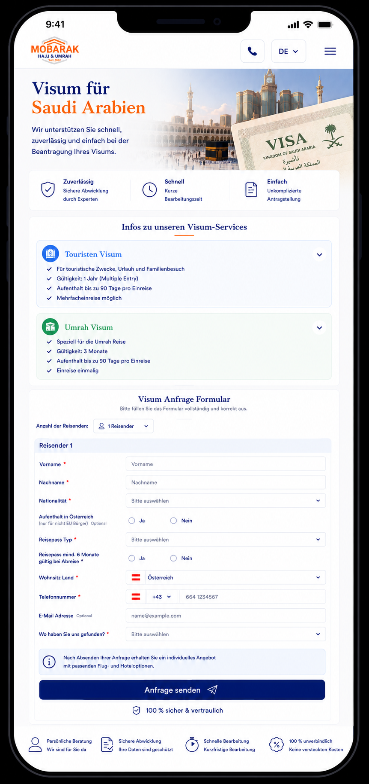
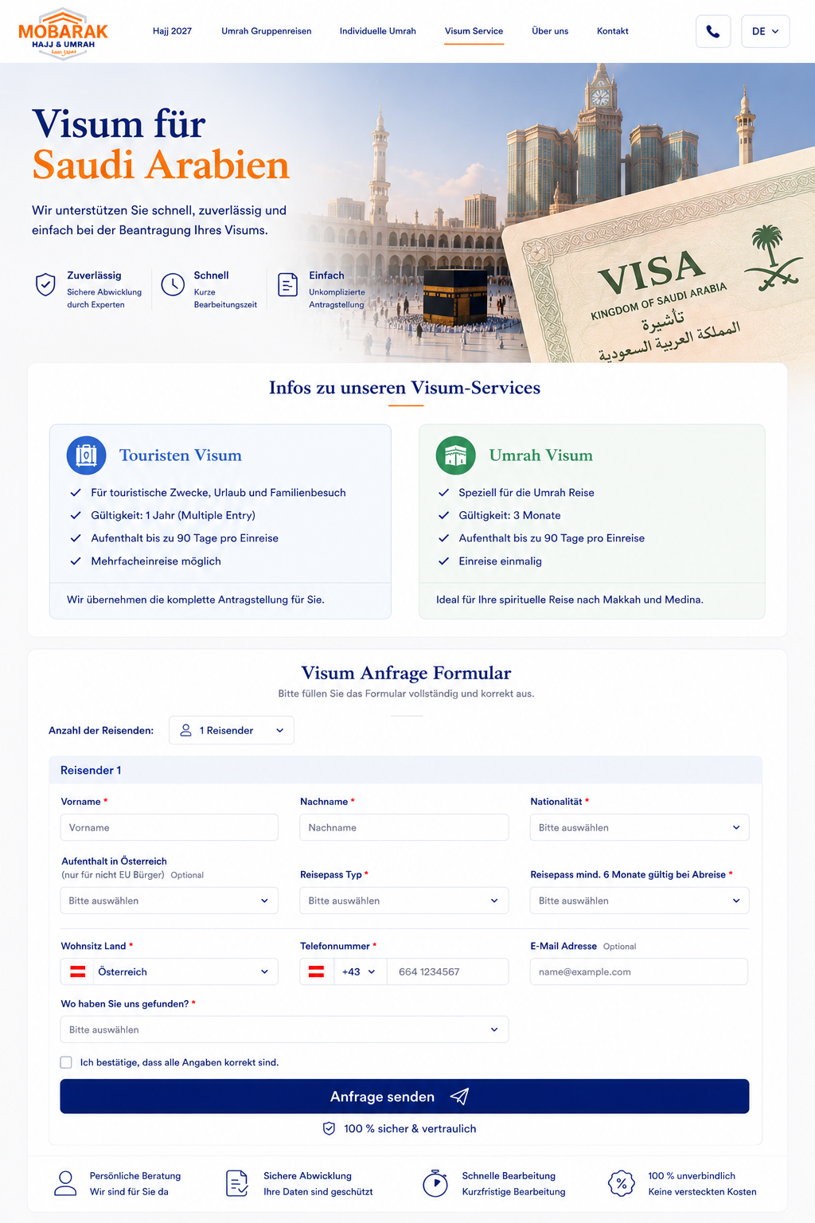Final Desktop & Mobile Developer Specification
Please use the two approved screenshots as the final visual reference for the Saudi Arabia Visa Service page.
We have approved:
- Desktop version
- Mobile / iPhone version
Please reproduce these designs as closely as possible regarding:
- Layout
- Spacing
- Typography
- Colors
- Icons
- Form styling
- Borders
- Shadows
- Card dimensions
- Responsive behaviour
- Hero proportions
Please do not redesign the page during implementation.

1. Page Purpose
This page is for customers who need assistance with obtaining a visa for Saudi Arabia.
The page has three main purposes:
- Explain the available visa options
- Collect the customer's visa inquiry
- Provide useful SEO information about Saudi Arabia visas and entry requirements
The main page navigation item is:
Visum Service

2. Desktop Header
Use the standard Mobarak header.
Left:
Mobarak Hajj & Umrah Logo
Navigation:
- Hajj 2027
- Umrah Gruppenreisen
- Individuelle Umrah
- Visum Service
- Über uns
- Kontakt
Visum Service must be shown as the active menu item with the orange underline.
Right:
- Phone button
- Language selector

3. Mobile Header
Use exactly the compact structure shown in the approved Mobile design.
Left:
Mobarak Hajj & Umrah Logo
Right:
- Phone icon
- Language selector
- Hamburger menu
Do not display the Desktop navigation links on Mobile.

4. Hero Section
Headline:
Visum für
Saudi Arabien
Use:
Visum für → dark Mobarak navy
Saudi Arabien → Mobarak orange
Supporting text:
Wir unterstützen Sie schnell, zuverlässig und einfach bei der Beantragung Ihres Visums.
The Hero image should visually communicate:
Saudi Arabia + Visa + Makkah
and not simply show a Saudi passport.
Use the approved visa-style visual from the design.

5. Hero Trust Elements
Show three benefits:
Zuverlässig
Sichere Abwicklung durch Experten
Schnell
Kurze Bearbeitungszeit
Einfach
Unkomplizierte Antragstellung
Use the same navy outline icon style as the approved design.
Desktop:
Display horizontally.
Mobile:
Keep all three visible in one compact horizontal section if the available width allows it.

6. Visa Information Section
Heading:
Infos zu unseren Visum-Services
Show two cards.
Do NOT show a business visa.
Only:
- Touristen Visum
- Umrah Visum

7. Touristen Visum
Blue card.
Title:
Touristen Visum
Content:
✓ Für touristische Zwecke, Urlaub und Familienbesuch
✓ Gültigkeit: 1 Jahr (Multiple Entry)
✓ Aufenthalt bis zu 90 Tage pro Einreise
✓ Mehrfacheinreise möglich
Bottom text:
Wir übernehmen die komplette Antragstellung für Sie.
Please keep the content editable from the admin/backend because visa regulations may change.

8. Umrah Visum
Green card.
Title:
Umrah Visum
Content:
✓ Speziell für die Umrah Reise
✓ Gültigkeit: 3 Monate
✓ Aufenthalt bis zu 90 Tage
✓ Einreise einmalig
Bottom text:
Ideal für Ihre spirituelle Reise nach Makkah und Medina.
Again, all visa information must be editable through the backend.

9. Mobile Visa Cards
On Mobile, display:
Touristen Visum
then directly underneath:
Umrah Visum
The cards should use almost the full available width.
The small arrow shown on the right can be used for expanding/collapsing additional information later.
However, in the current version the important basic information should already be visible.

10. Visa Inquiry Form
Heading:
Visum Anfrage Formular
Supporting text:
Bitte füllen Sie das Formular vollständig und korrekt aus.
Keep the form visually integrated into the page exactly as shown in the approved design.

11. Number of Travellers
First field:
Anzahl der Reisenden
Selector:
1 Reisender ▼
The user can select the number of people requiring visa assistance.
Based on this selection, dynamically create the corresponding number of traveller sections.
Example:
3 travellers selected
→ Reisender 1
→ Reisender 2
→ Reisender 3
Do not require the user to manually add each person.

12. Traveller Information
For every traveller collect:
Vorname *
Nachname *
Nationalität *
Aufenthalt in Österreich
nur für Nicht-EU-Bürger – optional
Reisepass Typ *
Reisepass mind. 6 Monate gültig bei Abreise *
The first and last name should be entered exactly as shown in the passport.

13. Nationality
Use a searchable country field.
The customer should be able to start typing.
Example:
Öst...
→ Österreich
Bos...
→ Bosnien und Herzegowina
Tür...
→ Türkei
etc.
Do not use a very long standard dropdown requiring excessive scrolling.

14. Aufenthalt in Österreich
Label:
Aufenthalt in Österreich
Small text:
(nur für nicht EU Bürger) – Optional
Options:
○ Ja
○ Nein
Important:
This field is optional.
It should primarily be relevant for non-EU citizens.
No option should be preselected.

15. Passport Type
Field:
Reisepass Typ *
Available options:
- Normaler Reisepass
- Konventionspass
- Travel Document
- Diplomatenpass
No default selection.

16. Passport Validity
Question:
Reisepass mind. 6 Monate gültig bei Abreise *
Options:
○ Ja
○ Nein
No default selection.
IMPORTANT:
If the customer selects:
Nein
show a warning underneath:
Ihr Reisepass erfüllt möglicherweise nicht die erforderliche Mindestgültigkeit für die Einreise nach Saudi-Arabien. Bitte kontaktieren Sie uns für weitere Informationen.
Do not automatically delete or block the inquiry.
We should still be able to receive the customer's request.

17. Residence Country
Field:
Wohnsitz Land *
Default:
🇦🇹 Österreich
Austria should be preselected.
However, the customer must be able to change it.
Use a searchable country selector.

18. Telephone Number
Field:
Telefonnummer *
Default country code:
🇦🇹 +43
Layout:
🇦🇹 | +43 ▼ | Telefonnummer
If the residence country changes, the telephone country code can automatically change accordingly.
However, the customer must always be able to manually change the telephone prefix.

19. Email Address
Field:
E-Mail Adresse
Small text:
Optional
Email is NOT required.
Do not display a required *.

20. How Did You Find Us?
Field:
Wo haben Sie uns gefunden? *
No default selection.
Options:
- Instagram
- Facebook
- Google
- ChatGPT
- Empfohlen von einem Freund
- Ich kenne euch schon
- Andere
If:
Andere
is selected, reveal an additional small text field:
Bitte angeben

21. Confirmation Checkbox
Before submitting:
☐ Ich bestätige, dass alle Angaben korrekt sind.
This must not be preselected.

22. Information Box
Above the CTA display the light-blue information box.
Please correct the wording compared with any older Individual-Umrah template.
This is a VISA inquiry.
Therefore use:
Nach Absenden Ihrer Anfrage prüfen wir Ihre Angaben und kontaktieren Sie bezüglich der weiteren Schritte für Ihren Visumantrag.
Do NOT write:
“Flug- und Hoteloptionen”
on the visa page.

23. CTA
Main CTA:
Anfrage senden
Use:
- Dark Mobarak blue
- White text
- Send icon
- Rounded corners
Desktop:
Wide button inside the form container.
Mobile:
Almost full width of the form.
The CTA should NOT be sticky.

24. Trust Message
Directly underneath:
🛡 100 % sicher & vertraulich
Then display:
Persönliche Beratung
Wir sind für Sie da
Sichere Abwicklung
Ihre Daten sind geschützt
Schnelle Bearbeitung
Kurzfristige Bearbeitung
100 % unverbindlich
Keine versteckten Kosten
Desktop:
One horizontal row.
Mobile:
Use the compact layout from the approved screenshot.

25. Desktop Form Layout
Follow the approved Desktop design.
Use multiple columns where appropriate.
Example:
Vorname | Nachname | Nationalität
Next row:
Aufenthalt Österreich | Reisepass Typ | Passgültigkeit
Next row:
Wohnsitz | Telefonnummer | E-Mail
Then:
Wo haben Sie uns gefunden?
Do not make fields unnecessarily large.

26. Mobile Form Layout
Follow the approved iPhone screenshot.
The Mobile design intentionally remains compact.
Labels should appear on the left where appropriate and fields on the right, as shown in the reference.
However, responsiveness is more important than forcing this structure on extremely narrow screens.
At smaller breakpoints, fields may move underneath their labels.
No horizontal scrolling is allowed.

27. Multiple Travellers on Mobile
If 3 travellers are selected, show:
Reisender 1
All fields
Reisender 2
All fields
Reisender 3
All fields
The sections should be clearly separated.
All traveller sections should initially be visible/open.

28. Multilingual Support
The complete page must support:
- German
- Arabic
- Turkish
- Bosnian
- English
This includes:
- Hero
- Visa descriptions
- Form labels
- Dropdown options
- Validation
- Information messages
- CTA
- SEO content
- Entry requirements
Arabic requires a proper RTL implementation.

29. NEW – SEO Content Below the Form
This is important.
After the complete form and trust section, add a dedicated content section for SEO.
This section is currently not shown in the approved screenshots, but it must be implemented underneath the existing design.
Do not place it between the Hero and the form.
The conversion-focused page should remain exactly as designed first.
Then underneath it we add the informational SEO content.

30. SEO Section Main Heading
Use:
Visum für Saudi-Arabien – Informationen zur Einreise
Introductory text:
Für eine Reise nach Saudi-Arabien benötigen Reisende abhängig von Nationalität, Reisepass und Reisezweck das passende Visum. Ob Sie Saudi-Arabien als Tourist besuchen oder für eine Umrah-Reise nach Makkah und Medina reisen möchten – wir unterstützen Sie bei der Auswahl und Beantragung des passenden Visums.

31. SEO Section – Tourist Visa
Subheading:
Touristenvisum für Saudi-Arabien
Text:
Das Touristenvisum ermöglicht berechtigten Reisenden touristische Aufenthalte in Saudi-Arabien. Das elektronische Touristenvisum kann je nach Voraussetzungen als Multiple-Entry-Visum ausgestellt werden und ermöglicht Aufenthalte von bis zu 90 Tagen. Auch eine Umrah kann grundsätzlich mit einem entsprechenden Touristenvisum durchgeführt werden, sofern die jeweils geltenden Bestimmungen erfüllt werden. Das Touristenvisum ist nicht für die Teilnahme am Hajj bestimmt.

32. SEO Section – Umrah
Subheading:
Visum für Umrah in Saudi-Arabien
Text:
Für eine Umrah-Reise nach Makkah und Medina gelten je nach Nationalität und persönlicher Situation unterschiedliche Möglichkeiten der Visumbeantragung. Wir prüfen Ihre Angaben und unterstützen Sie dabei, die für Ihre Reise geeignete Visumlösung zu finden.
Important:
Do not hard-code visa eligibility based only on nationality without backend logic.

33. SEO Section – Entry Requirements
Subheading:
Einreisebestimmungen für Saudi-Arabien
Use a visually clean checklist/card.
Example:
Reisepass
Für das touristische eVisa muss der verwendete Reisepass bei der Einreise nach Saudi-Arabien grundsätzlich noch mindestens sechs Monate gültig sein.
Gültiges Visum
Vor der Einreise muss ein für den jeweiligen Reisezweck gültiges Visum vorliegen.
Richtiger Reisepass
Für die Einreise muss grundsätzlich derselbe Reisepass verwendet werden, mit dem das eVisa beantragt wurde.
Einreiseentscheidung
Auch ein ausgestelltes Visum garantiert die Einreise nicht automatisch. Die endgültige Entscheidung über die Einreise liegt bei den zuständigen saudischen Behörden.

34. Important SEO Disclaimer
At the end of the SEO section add:
Hinweis: Visabestimmungen und Einreisevoraussetzungen können sich kurzfristig ändern und hängen unter anderem von Nationalität, Reisepass, Aufenthaltsstatus und Reisezweck ab. Die Angaben auf dieser Seite dienen der allgemeinen Information. Vor der Beantragung prüfen wir die für Ihre persönliche Situation geltenden Voraussetzungen.
This is important because visa requirements can change.

35. SEO Content Must Be Editable
Very important for the backend:
All SEO content must be editable from the Admin Panel.
We need editable fields for:
- H1/H2 headings
- Paragraphs
- Visa information
- Entry requirements
- FAQ
- Meta title
- Meta description
- Internal links
- Structured content
Do NOT hard-code the visa rules permanently into the frontend.

36. Recommended FAQ Section
Under the SEO text add:
Häufige Fragen zum Saudi-Arabien Visum
Use accordions.
Suggested questions:
Wie lange muss mein Reisepass gültig sein?
Kann ich mit einem Touristenvisum Umrah machen?
Wie lange darf ich in Saudi-Arabien bleiben?
Benötigen Kinder ein eigenes Visum?
Kann ich mit einem Konventionspass ein Visum beantragen?
Welche Unterlagen benötige ich?
Wie lange dauert die Bearbeitung?
Kann Mobarak den Visumantrag für mich übernehmen?
All FAQ answers must be editable through the admin panel.

37. SEO Technical Requirements
Please implement proper SEO fundamentals:
- One clear H1
- Logical H2/H3 hierarchy
- Editable meta title
- Editable meta description
- Canonical URL
- Open Graph data
- Breadcrumbs where appropriate
- FAQ structured data only when the displayed content meets Google's requirements
- Server-rendered/indexable SEO text
- Do not load the SEO content only through JavaScript after page load
- Correct hreflang implementation for all language versions
For Arabic:
dir="rtl"
and correct Arabic language metadata.

38. Important Visa Data Architecture
Visa regulations can change.
Therefore please separate:
Design/content
from:
visa rules/data
as much as possible.
For example, these values should be editable:
- Visa validity
- Maximum stay
- Multiple/single entry
- Passport validity requirements
- Eligible nationalities
- Visa types
- Required documents
- Notices/warnings
This allows us to update the website without changing code.

39. Final Page Structure – Desktop
The final Desktop page should therefore be:
Header
↓
Hero – Visum für Saudi Arabien
↓
Zuverlässig / Schnell / Einfach
↓
Infos zu unseren Visum-Services
↓
Touristen Visum + Umrah Visum
↓
Visum Anfrage Formular
↓
Trust Elements
↓
SEO: Visum für Saudi-Arabien – Informationen zur Einreise
↓
Touristenvisum
↓
Umrah / Visum
↓
Einreisebestimmungen
↓
FAQ
↓
Footer

40. Final Page Structure – Mobile
Mobile follows exactly the approved iPhone design:
Compact Header
↓
Hero
↓
3 Benefits
↓
Visa Information
↓
Touristen Visum
↓
Umrah Visum
↓
Visa Inquiry Form
↓
Trust Elements
↓
Then the NEW SEO section:
Visum für Saudi-Arabien – Informationen zur Einreise
↓
Touristenvisum
↓
Umrah
↓
Einreisebestimmungen
↓
FAQ
↓
Footer
The SEO area should be optimized for reading on Mobile with short paragraphs, good spacing and accordions.

41. Most Important Instruction
The two supplied screenshots are now the approved final visual references.
Please keep the visible upper part of the page as close as possible to these screenshots.
The only major addition is:
A complete SEO/information section underneath the existing form design.
This SEO section must cover:
Saudi Arabia Visa
Tourist Visa
Umrah Visa
Saudi Arabia Entry Requirements
and should be fully manageable through the Admin Panel.

